

MATLAB-Experiment 5A

Divergence, Curl and Gradient and visualization of vector field



APRIL 9, 2021

BIMAL PARAJULI

20BDS0405

Department of Mathematics

School of Advanced Sciences

MAT 1011 – Calculus for Engineers (MATLAB)

Experiment 5-A

Divergence, Curl and Gradient and visualization of vector field

Prepared by: Bimal parajuli

Registration Number: 20BDS0405

1. **Draw the two dimensional vector field for the vector 2xi + 3yj**

**CODE:**

% Draw the two dimensional vector field for the vector 2x i + 3y j.

close all ;

clear;

clc;

syms x y z;

%given function

func = [2*x,3*y];

% div = curl(func, [x, y])

fx(x, y) = func(1);

fy(x, y) = func(2);

[xcord, ycord] = meshgrid(linspace(-2,2,10));

u = fx(xcord, ycord);

v = fy(xcord, ycord);

figure(1);

% pcolor(xcords, ycords, div(xcords, ycords));

hold on;

grid on;

quiver(xcord, ycord, u, v);

xlabel("X-axis");

ylabel("Y-axis");

title("Vector field of function f(x,y)");

hold off;

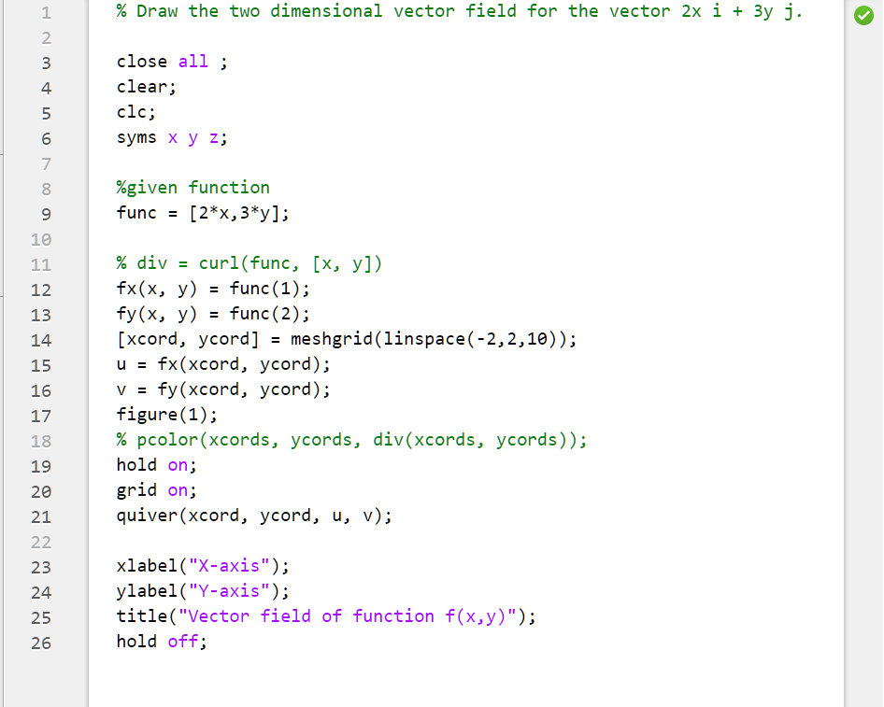

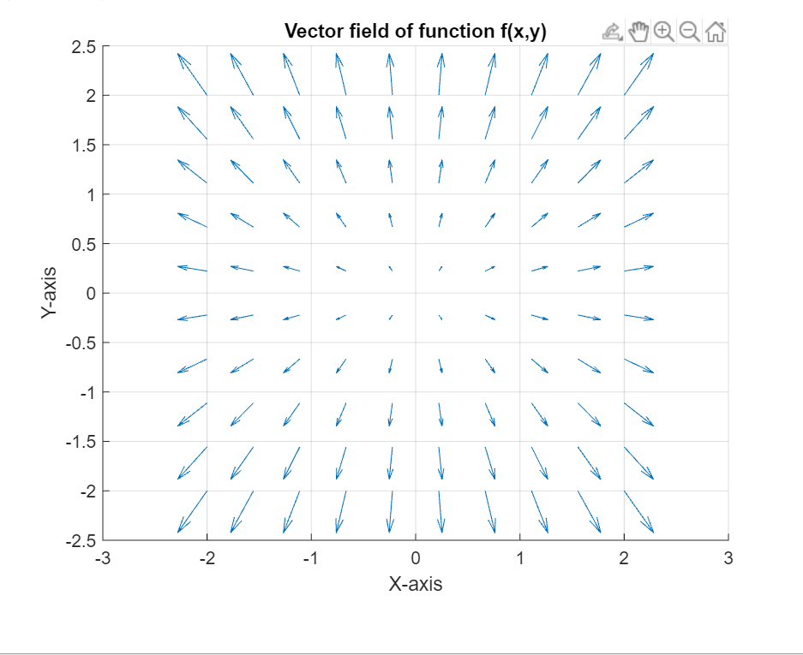

1. **Find the Gradient of the function 𝑓 = 𝑥2𝑦3 – 4y.**

**CODE:**

% Find the Gradient of the function f=x^2 y^3- 4y.

close all ;

clear all;

clc;

syms x y z;

func = (x^(2))*(y^(3))- 4*y;

disp("The gradient of the function is ");

grad = gradient(func, [x, y]);

disp(grad);

fx(x, y) = grad(1);

fy(x, y) = grad(2);

[xcord, ycord] = meshgrid(linspace(-4, 4, 10));

u = fx(xcord, ycord);

v = fy(xcord, ycord);

figure(1);

hold on;

grid on;

quiver(xcord, ycord, u, v, 2);

xlabel("X-axis");

ylabel("Y-axis");

title("Gradient of function f(x,y)");

hold off;

**OUTPUT:**

The gradient of the function is

2*x*y^3  
3*x^2*y^2 - 4

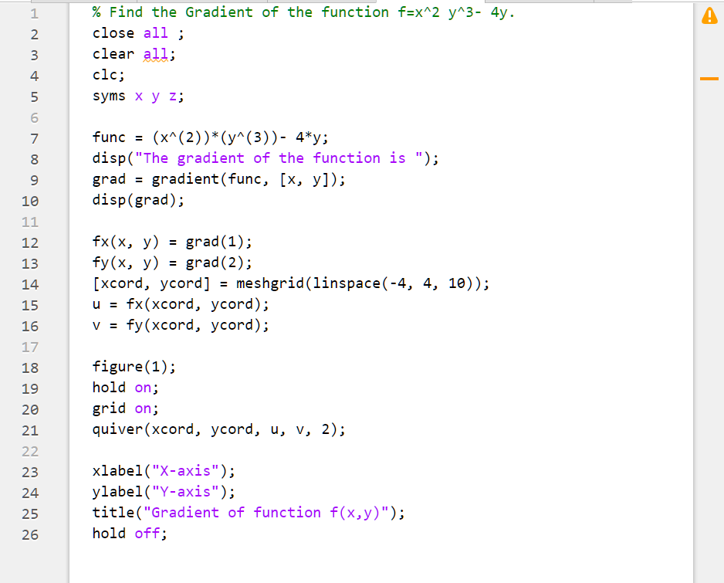

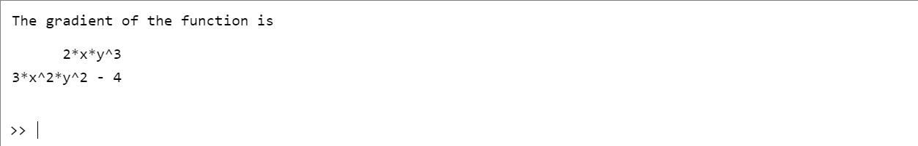

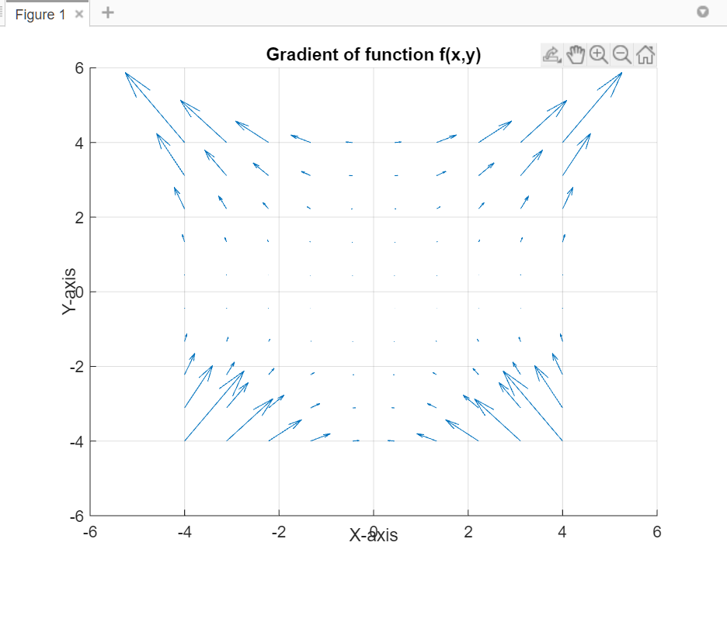

1. Find the divergence of a vector field f=[xy,x2].

**CODES:**

% Draw the two dimensional vector field for the vector 2x i + 3y j.

close all ;

clear all;

clc;

syms x y z;

func = [x*y,x^2];

div(x,y) = divergence(func, [x, y]);

fx(x, y) = func(1); fy(x, y) = func(2);

[xcords, ycords] = meshgrid(linspace(-2,2,10));

u = fx(xcords, ycords);

v = fy(xcords, ycords);

figure(1);

pcolor(xcords, ycords, div(xcords, ycords));

shading interp;

hold on;

grid on;

quiver(xcords, ycords, u, v);

xlabel("X-axis");

ylabel("Y-axis");

title("Vector field of function f(x,y)");

hold off;

**OUTPUT:**

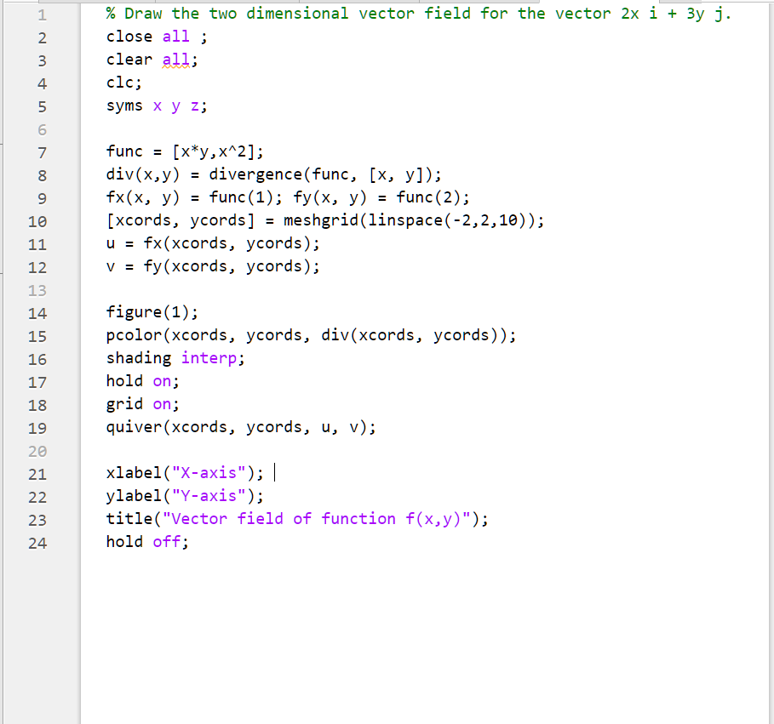

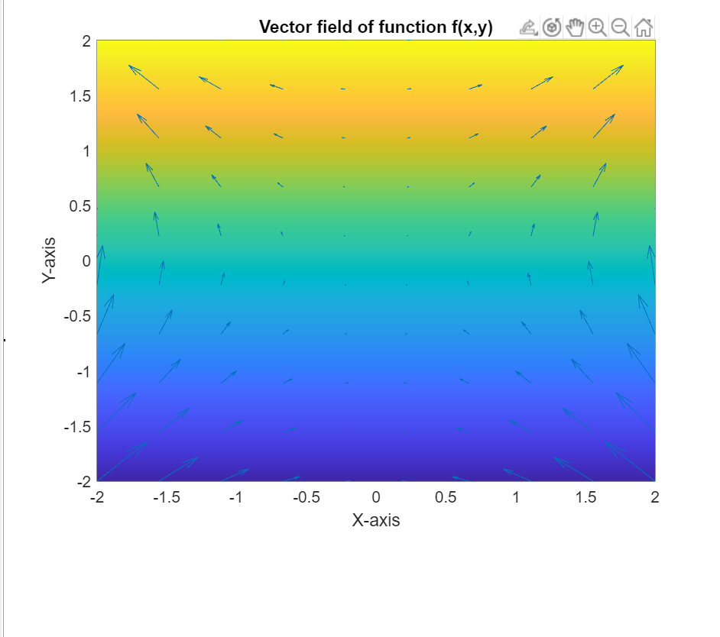

1. **Visualize the curl of a vector function**

**f =[yz 3, 3zx, z].**

**CODES:**

% Visualize the curl of a vector function f = [y*z, 3*z*x, z].

close;

clear all;

clc;

syms x y z;

func = [y*z,3*z*x,z];

disp("The curl of the function is ");

cur = curl(func, [x, y, z]);

disp(cur);

[xcords, ycords, zcords] = meshgrid(linspace(-3, 3, 5));

fx(x, y, z) = func(1);

fy(x, y, z) = func(2);

fz(x, y, z) = func(3);

u = fx(xcords, ycords, zcords);

v = fy(xcords, ycords, zcords);

w = fz(xcords, ycords, zcords);

figure(1);

quiver3(xcords, ycords, zcords, u, v, w);

hold on;

grid on;

xlabel("X-axis");

ylabel("Y-axis");

zlabel("Z-axiz");

title("3D view of vector field");

hold off;

figure(2)

% curl view

curlx(x, y, z) = cur(1);

curly(x, y, z) = cur(2);

curlz(x, y, z) = cur(3);

curl1 = curlx(xcords, ycords, zcords);

curl2 = curly(xcords, ycords, zcords);

curl3 = curlz(xcords, ycords, zcords);

quiver3(xcords, ycords, zcords, curl1, curl2, curl3);

hold on;

grid on;

xlabel("X-axis");

ylabel("Y-axis");

zlabel("Z-axiz");

title("3D view of curl");

hold off;

